Neumann M 49 Inducted into NAMM's TECnology Hall of Fame, While Sennheiser and Neumann are Both Recognized at 39th Annual NAMM TEC Awards
Sennheiser's EW-DX Wireless Microphone System and M 49 V Tube Microphone Capture Outstanding Technical Achievement Awards

Anaheim, CA, January 30, 2024 — Sennheiser and Neumann were both recognized for Outstanding Technical Achievement during the 39th Annual NAMM TEC Awards, held on Saturday evening at the Anaheim Convention Center in California. Sennheiser captured a TEC Award with its EW-DX wireless microphone system, while Neumann received a TEC Award for its M 49 V Tube Microphone in the respective categories of Wireless Technology and Microphones – Recording. With this, Neumann's legendary M 49 (1951) microphone was inducted into the 2024 class of the NAMM TECnology Hall of Fame.
Neumann CEO Ralf Oehl and Head of Sales and Business Development, Jonathan Ruest, accept the TEC Award for the M 49 V in the Microphones – Recording category.

Now in its 39th year, the TEC Awards are widely regarded as the highest honor dedicated to the pro audio and sound recording industry, recognizing outstanding performance by the individuals, companies and technical innovations behind the sound of recordings, live performances, films, television, video games and multimedia.

Winning in the Wireless Technology category is Sennheiser's newest addition to the Evolution Wireless Digital family, EW-DX. This wireless system takes the complexities out of wireless audio by employing sophisticated tools that streamline the setup and monitoring process. With the press of a button, Auto Scan automatically assigns channels using an equidistant tuning grid, allowing operators to pack more channels more reliably – without problematic intermodulation interference. With its advanced feature set and hardware options, EW-DX is a scalable solution that is perfect for live performance.
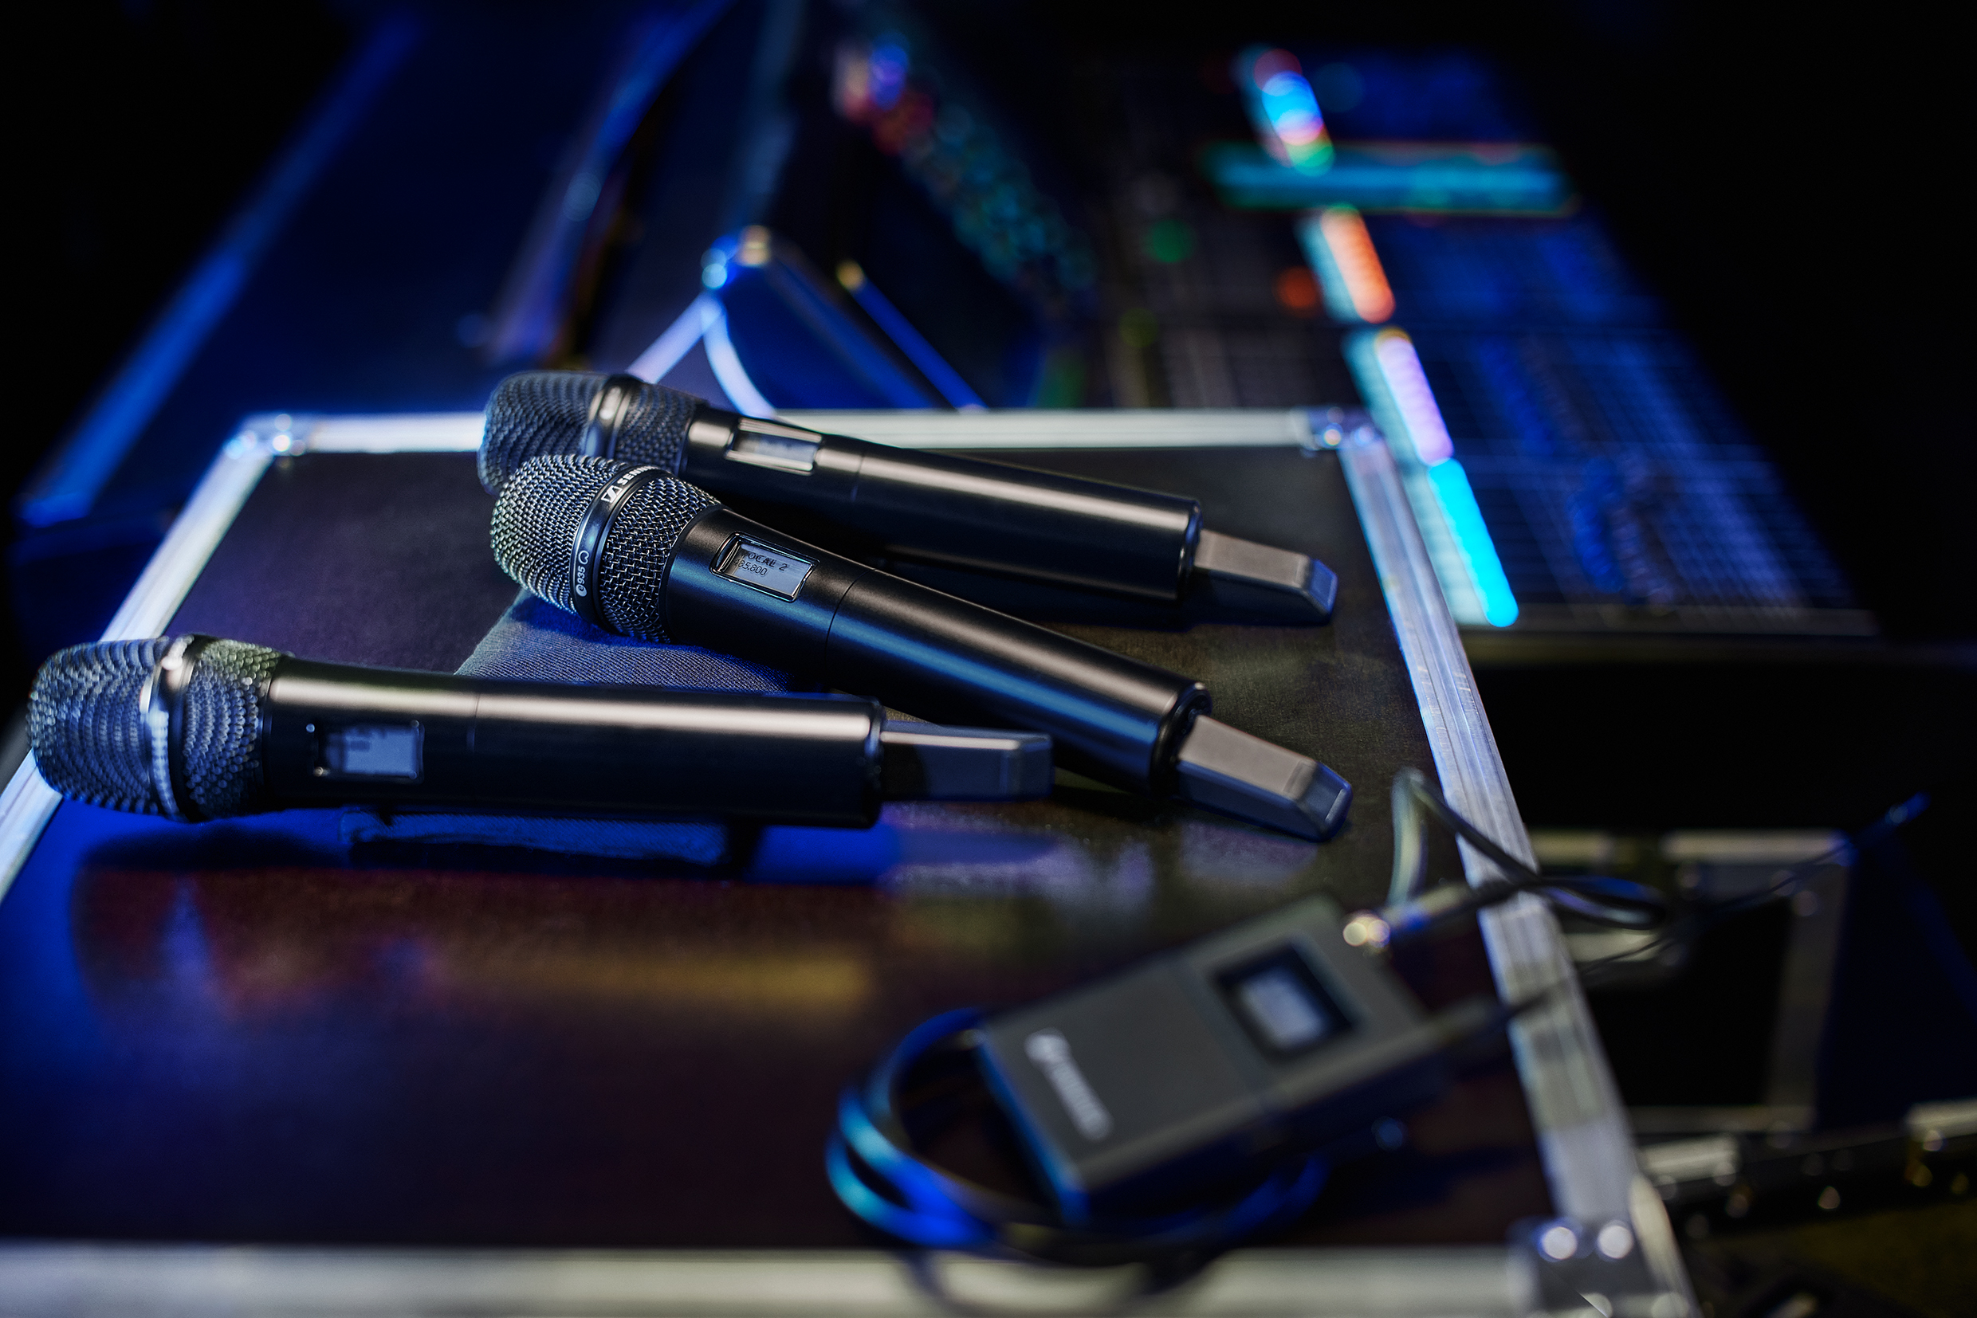
The flexible and scalable Sennheiser EW-DX Wireless System took home the TEC Award in the Wireless Technology category.

“Receiving an Outstanding Technical Achievement award is an inspiration for Sennheiser as we continue to serve our customers around the world,” commented Greg Beebe, Executive Vice President, Professional Audio at Sennheiser. "We are thrilled that the NAMM Foundation has recognized the EW-DX wireless microphone system, an innovative digital product that we are particularly proud of.”

A TEC Award in the Microphones – Recording category went to the Neumann M 49 V Set, a faithful reissue of the legendary M 49. Introduced in 1951, the M 49 revolutionized studio technology with its continuously variable, remote-switchable polar pattern. Thanks to its balanced frequency response in all directional patterns from omnidirectional to cardioid to figure-8, including intermediate settings, the M 49 is a truly universal microphone: be it orchestra, piano, trumpet, or vocals, the M 49 is suitable for recordings of all kinds to the highest standard. More than 70 years after its initial release, the M 49 V makes its classic sound available again.
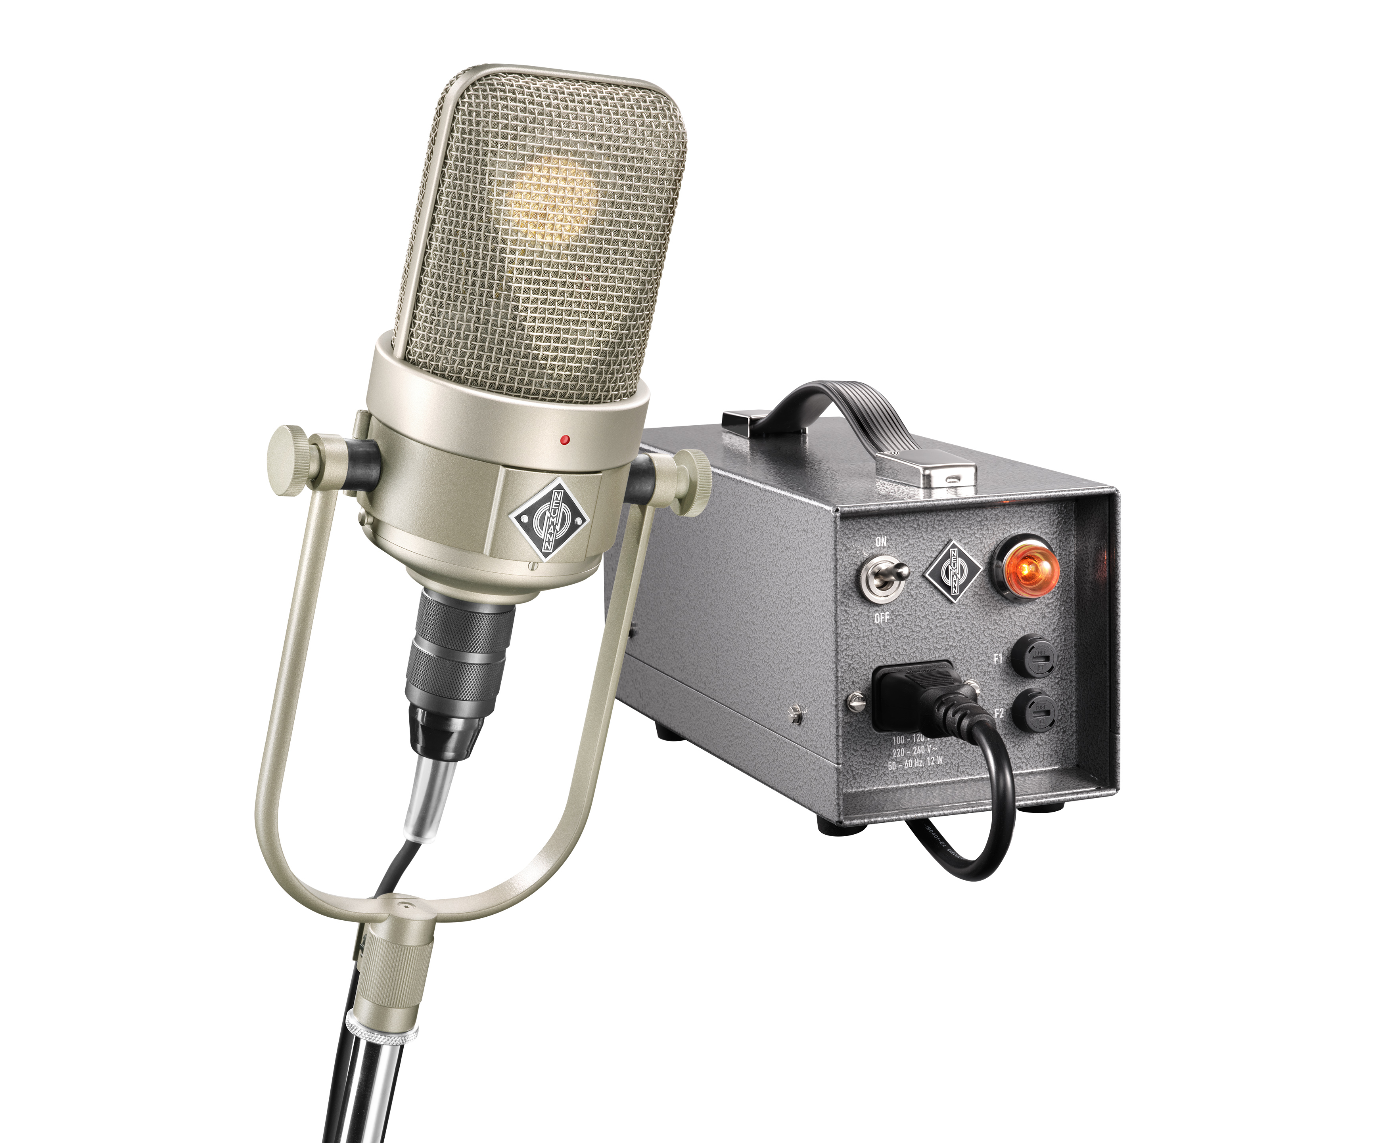
The M 49 V Tube Microphone Set won the TEC Award for Microphones – Recording, a fitting honor after its predecessor the M 49 was inducted into the TECnology Hall of Fame.

“We are delighted that Neumann has once again been honored with a TEC Award for Outstanding Technical Achievement,” stated Neumann’s CEO Ralf Oehl. “I see this as amazing encouragement and recognition for our team that works so hard to continue Neumann’s almost 100-year legacy of being recognized as the reference in the pro audio community.”

Neumann M 49 (1951) inducted into the TECnology Hall of Fame
While the M 49 V reissue received a TEC Award for Outstanding Technical Achievement, the classic Neumann M 49 (1951) was among this year's inductees into the TECnology Hall of Fame. Neumann.Berlin CEO Ralf Oehl was on hand to accept the award in a ceremony held prior to the NAMM TEC Award reception. This marks Neumann’s ninth induction into the TECnology Hall of Fame, making the manufacturer the most decorated company in the Hall of Fame’s 20-year history. The M 49 variable pattern tube microphone joins previous inductees from Neumann including, but not limited to, the U 47 condenser mic (1949), the KM 84 small diaphragm condenser mic (1966), the CMV 3, the first mass-produced condenser mic (1928) and more.
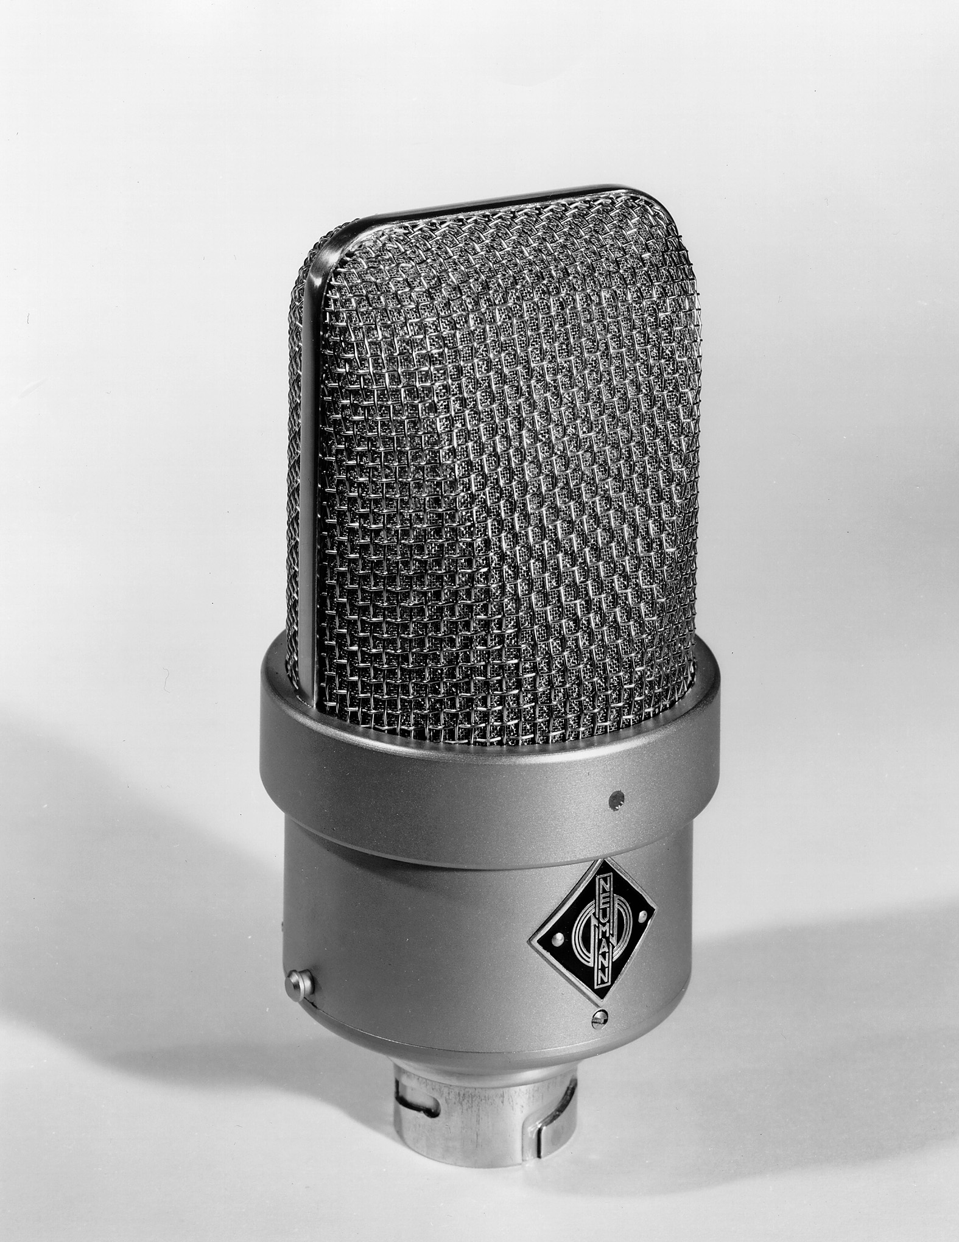 | The M 49 joined the NAMM TECnology Hall of Fame in 2024, 73 years after its introduction.

Designed on contract for the IRT (the governmental regulating arm of the German broadcast system) the Neumann M 49 debuted in 1951 and was an instant success. Its sound can be heard on the classic recordings of the time, and it was known for its distinct sound character on nearly any source – particularly on female vocals.

Founded in 2004 by noted audio and music journalist George Petersen as a historic adjunct to the annual TEC (Technical Excellence and Creativity) Awards, and presented since 2015 by the NAMM Museum of Making Music, the TECnology Hall of Fame honors products and innovations that have made significant contributions to the advancement of audio and music technology.
“In 1951, the Neumann M 49 took the concept of the U 47 to the next step, adding a full range of remotely controllable polar patterns — from omni to cardioid to figure-8,” says noted journalist and NAMM TECnology Hall of Fame founder and director George Petersen. “At the same time, it appealed to broadcasters in the new television market who were seeking a more compact microphone for on-air use. And by using the same capsule as the U 47, the M 49 was an instant hit and even today remains a studio classic.”

“It is remarkable that the M 49 is being inducted into the TECnology Hall of Fame shortly after we finally managed to bring this coveted microphone back to the market with overwhelming success,” commented Ralf Oehl, CEO of Neumann.Berlin. “With now nine products in the Hall of Fame, we feel vindicated to continue nurturing our unique heritage while bringing newer product lines such as studio monitors, headphones and audio interfaces to the same iconic level and recognition.”

About the Sennheiser Group
Building the future of audio and creating unique sound experiences for our customers - this is the aspiration that unites the employees of the Sennheiser Group worldwide. The independent family-owned company Sennheiser was founded in 1945. Today, it is managed in the third generation by Dr. Andreas Sennheiser and Daniel Sennheiser and is one of the leading manufacturers in the field of professional audio technology. Within the Sennheiser Group are Georg Neumann GmbH (Berlin, Germany), manufacturer of studio-grade audio equipment; Dear Reality GmbH (Düsseldorf, Germany), known for its binaural, Ambisonics, and multichannel encoders with realistic room virtualization; and Merging Technologies SA (Puidoux, Switzerland), specialist in high-resolution digital audio recording systems.
sennheiser.com | neumann.com | dear-reality.com | merging.com

Local Press Contacts
Daniella Kohan Jeff Touzeau
daniella.kohan@sennheiser.com jeff@hummingbirdmedia.com
+1 (860) 227-2235 + 1 (914) 602-2913

